Tips and Notes

KEYBOARD SHORTCUTS
You can watch the video or just read the list in the body of the article. Don’t try and learn them all by heart straight away, start by learning the navigation shortcuts and those associated with the brush tool.
https://fstoppers.com/commercial/essential-keyboard-shortcuts-every-photoshop-user-should-know-178451

ADVANCED TIPS AND TRIcKS FOR PHOTOSHOP
https://fstoppers.com/education/22-photoshop-tricks-you-probably-didnt-know-about-413671

LIGHTROOM HINTS AND TIPS
https://fstoppers.com/education/three-helpful-lightroom-tips-any-photographer-415104
https://fstoppers.com/education/five-great-adobe-lightroom-tips-196506
https://fstoppers.com/lightroom/five-hidden-lightroom-tips-you-should-know-333131

Notes from the Demo
Please note the examples are from Photoshop Elements 11, but, they should translate to the other Adobe products. If you find any errors please tell Isobel Lindsay and they’ll be corrected.
Selections
Use the Quick Selection brush to automatically select an area, based on where you click, which you can then add to or subtract from. This brush can be found in the ‘Select’ area of the tools. Click on the tool and the 3 options become visible in the tool option section at the bottom. Simply click where you want to select and the brush will guess the area based on contrast or changes in colour with the next areas.
The marching ants will become visible as you select, or deselect, different areas. Make the brush larger and smaller using [ and ] keys. Hold the Alt key to swap from adding and subtracting from the selection –start with ‘add’ and then when you hold down the Alt key you will move to ‘Subtract’. Then when you let go of the Alt key it goes back to adding. NB: The Selection brush can also be used to select too – it simply selects the area over which you sweep the brush (in the shape of the brush).
The lozenge shape on the left was selected using the Selection brush. The flowers were selected with the Quick Selection brush and it uses the difference between the flower and the grass to work out where to draw the edges of the selection.
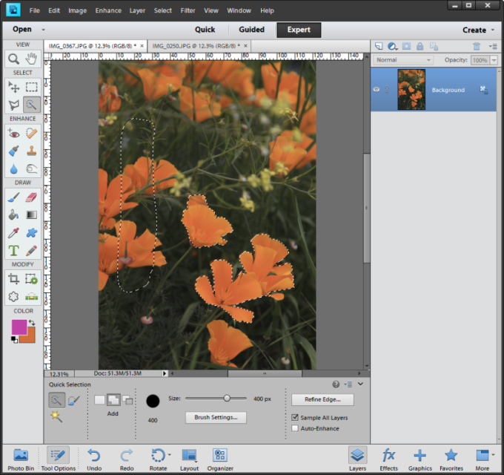
When you think you’ve got a good selection as a starter you should duplicate the layer by right clicking and selecting ‘duplicate layer’ or dragging the layer up to the new layer icon above ‘normal’ (it looks like a page with the corner turned over). The marching ants will remain visible after the second layer appears.
Make sure you have the new layer selected and click the add layer mask icon (circle in a square) – which will create a mask with the selection in white. The mask thumbnail will appear to the right of the layer thumbnail – it’s the black and white thumbnail. Then turn off the original layer so you can just see the selection floating on a checkerboard background. In the simplest case the original layer will be the background. Click on the mask thumbnail (the one on the right) to select the mask and the foreground and background colours will become black and white.
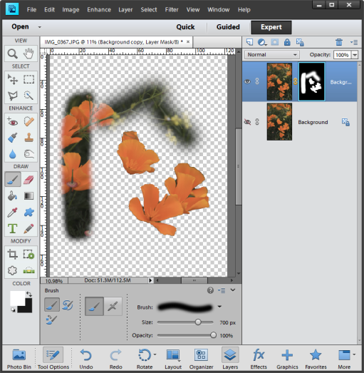
Click on the brush icon in the ‘Draw’ area of the tools. Then make sure the mode is ‘normal’ in the tool options area (or sometimes you won’t see it do anything). Then paint in white onto the mask to reveal more of the underlying image or paint in black to hide more of the underlying image. Press the X key to swap between white and black when you are painting. Use the [ ]’s to make the brush bigger and smaller as you work. Press and hold the Shift key and while you press [ or ] to make the brush harder or softer. If you want to see the marching ants press the control key when you click on the mask. Zoom in and out to check your selection is what you want.
When you’re happy with the selection right click on the mask thumbnail and click ‘apply layer mask’. This deletes everything that wasn’t visible in the mask – leaving the selection by itself on the layer.
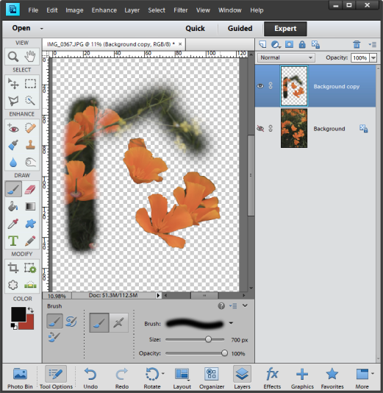
The layer can then be copied to another image. To do so you need to open the image which you want to copy into. Then go back to the image that you want to copy from and click on the layer you want to copy. You can then either drag the layer from the first image to the second one. Or alternatively go to the image with the layer you want to copy and click on the layer you want to copy. Then go to Select > All. Then Edit > copy. Then go to the image you wish the layer to be copied into and go to edit > paste. In shortcut terms it’s Control A, Control C and then Control V after you’ve moved to the second image.
It should be noted that you can (in some software) select using a colour range which you select on the image and then you add to it using other methods. The example is in Elements 11 and doesn’t have that functionality.

Blending Modes
You can really change the look of an image by adding a texture to it, or a different image, and simply changing the blending mode that is used in each layer. The software uses mathematics to work out the changes in colour using the differences between the two layers and different calculations for each blend mode. You can use lots and lots of these layers making complex visual changes without actually affecting each layer.
All you need to do is put two layers into the same file – here I chose a mountain and some flowers. Then click on the blend mode for the upper layer and change it from ‘normal’ to one of the others. Below you can see the impact of 3 different blending modes. Just imagine what you could do with more layers, different modes and the judicious use of opacity.
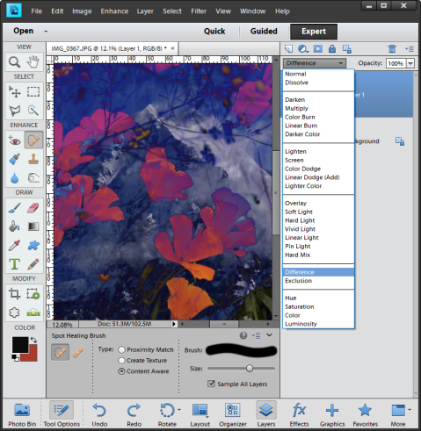
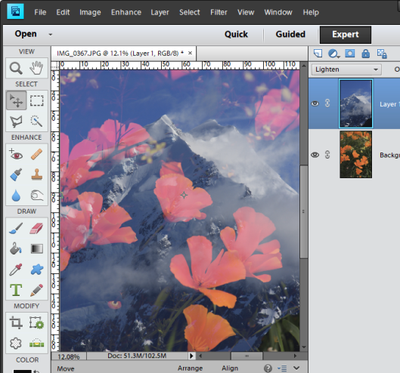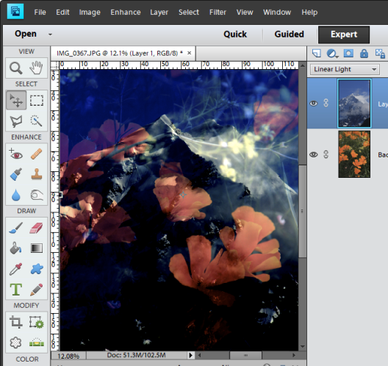

The best tools to clean up your images
The underlying rule for a good image is – if it shouldn’t be there then remove it. On a portrait this may be a stray hair or a blemish and on a landscape it might be a tree limb or bit of grass.
When you want to hide/remove something the clone tool is an old favourite. But, it is a bit clumsy in that it simply copies pixels you’ve selected and puts them in a new place. These two tools have the same effect, but, they are much more sensitive due to the way they blend the pixels together. Here are a couple of good video’s.
https://helpx.adobe.com/photoshop/how-to/spot-healing-brush-tool.html
https://www.youtube.com/watch?v=uNWL5QQrKyE
The trick is to work on a blank layer and not on the actual image you want to edit. This is critical to ensuring that you are working in a non-destructive way. It also ensures that you can put different edits on different layers and then make fixes to each of them much more easily. Suggestion is to have a layer for blemishes, one for hair removal, one for eye brightening, one for dodging and burning etc etc.
So to clean things up you firstly click on the layer you want to work on and click on ‘create new layer’ which is a page with a corner turned over. Then select the healing brush tool from the “Enhance” area of the tools – it’s a sticking plaster icon in Elements. You then see the tool options in the tool section of the screen. If it isn’t selected click on ‘spot healing brush’, (on the left in the example). Then make sure you select to Sample All Layers and be Content Aware. Then use the [ ] keys to make the brush smaller or larger, and hold down the shift key while using [ ] to make the brush softer and harder, as you need.
Simply click or drag the brush along what you want to vanish and the software will work out what you don’t want to see. The software uses the pixels in the selected ‘spot’ to work out what to remove and what to replace those pixels with. Watch things just vanish! You’ll see the edits building up on the blank layer so they havn’t really vanished – they are just hidden from view.
Alternatively, select the ‘healing brush’ (on the right below). Like the clone took you hold down the ‘alt’ key and click in the place you want the pixels to be copied from. Then click and drag the mouse in the place you want them put. Very like the clone tool, but, when you stop the software uses it’s computing power to blend the old pixels with the new ones so it looks much less clumsy.
The example below isn’t particularly helping in showing the effect, but, does show what the tool options are.
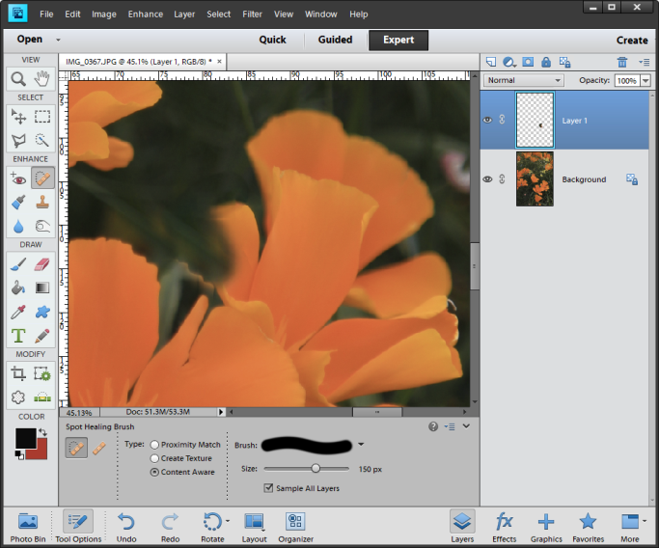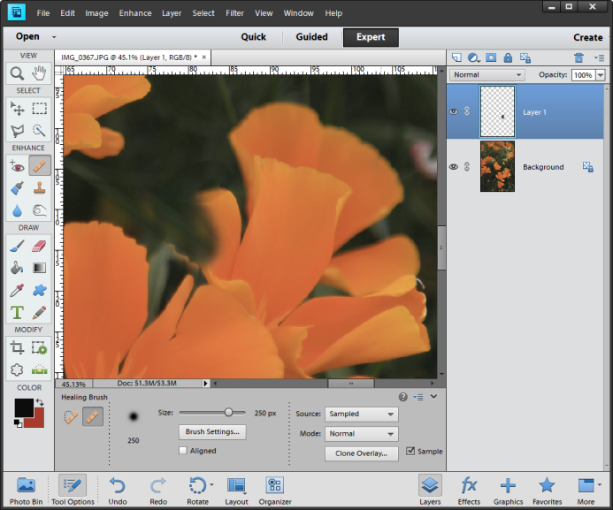

Lightening or darkening something
Again you start by creating a new blank layer above the layer you wish to change. Change the blending mode on the new layer to soft light and 22% opacity (although this might change depending on what you want to happen). For example lightening an eye is very delicate so may need a lower opacity, but, lightening a catchlight may need much less as you want the effect to be stronger.
Click on the brush icon in the ‘Draw’ area of the tools. Now choose the colour you want to paint with. To lighten something the easiest choice might be white, but, you could choose a lighter version of the existing colour to make even more subtle changes.
To select a specific colour you use the colour picker (also in the ‘Draw’ area of the tools). To select the colour, simply click on the colour in a layer and you’ll see the foreground colour change. If you want to change it click on the foreground colour and the colour picker box will appear. You can then move your selection upwards for a lighter shade (and down for a darker one). You can also choose black or white to dodge or burn an image. 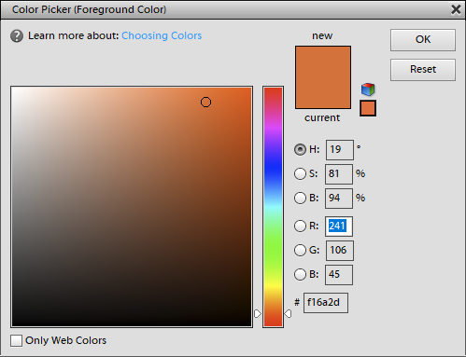
Having selected your colour (it will be the foreground colour), you need to make the brush the size you want. Then check that you are on the blank layer (and not the layer with the image on it) and paint away. As it’s on a separate layer you can add or remove as you wish. If you are lightening an eye you might only lighten half of it as subtlety is the aim of that edit – if you notice it it’s too much. It should enhance the image and not call attention to itself.
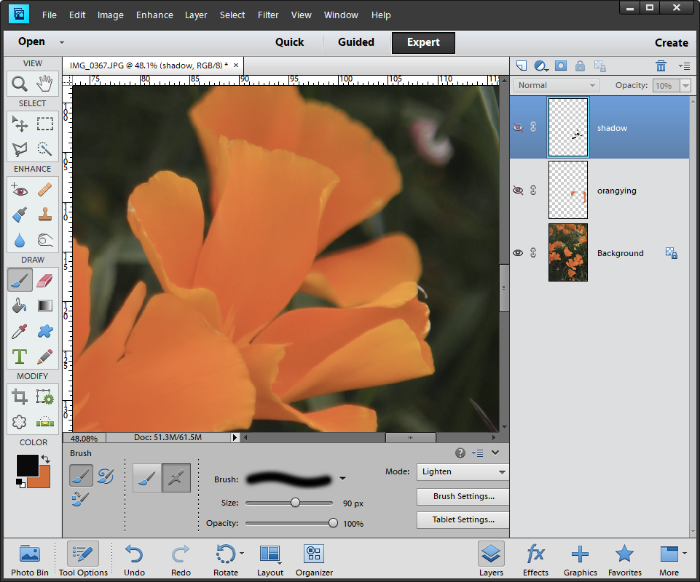
This shows my original image with two extra 2 layers on the right hand side – one to create an orange halo and one to shade the flowers. Both layers are turned off so you can see the original image.
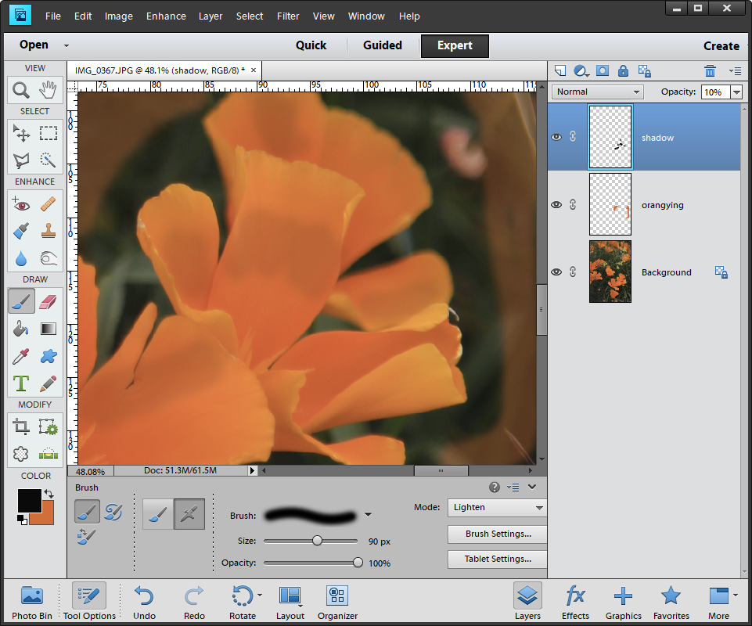
This is the image after both layers are turned on. Neither layer is affecting the underlying image and can be amended separately. The blend modes, opacity and actual painting on each can be changed independently.

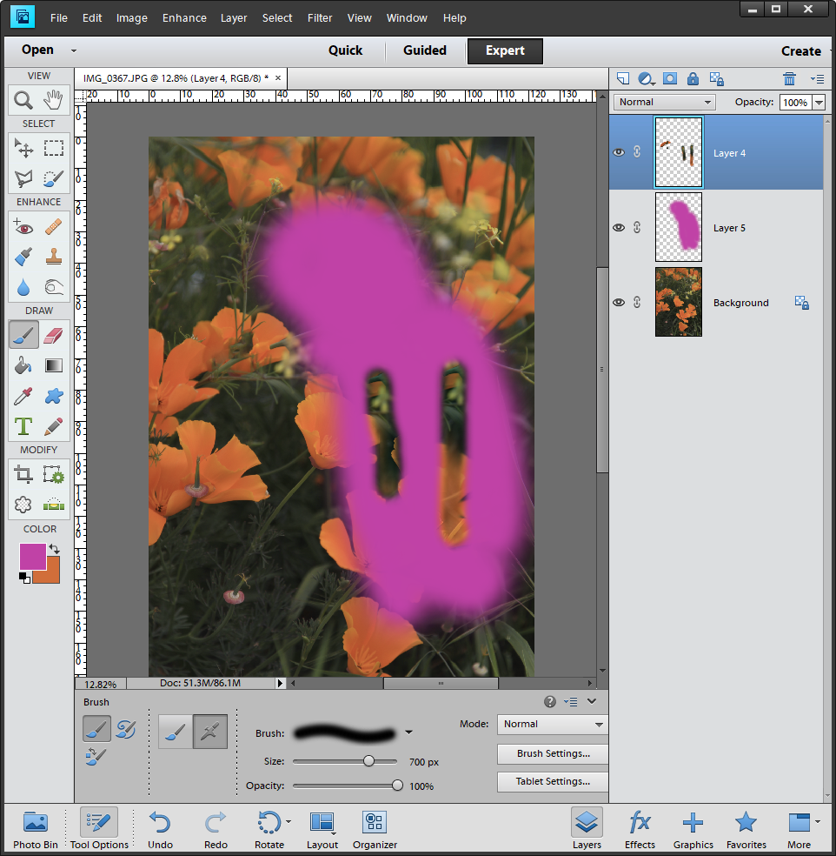
Remember that whatever you do is affected by the order of your layers. Here I’ve painted a large area pink, but, it looks like I’ve managed to create a window because the top most layer contains part of the underlying image and is covering the painted area.

